MARMARA UNIVERSITY
FACULTY OF ENGINEERING
COMPUTER ENGINEERING

PHYS1104
PHYSICS LABORATORY
EXPERIMENT 2
Serial and Parallel Resistors Circuits
SXGXE2

NAME | STUDENT NUMBER

Submitted to: Hüseyin YALTIRIK

Experiment Date: 09.03.2020 Due Date: 16.03.2020
1-) PURPOSE
The first aim of this experiment is how to set up a series combination of resistors, resistors in parallel combination and series and parallel combination of resistors, the second goal is to measure the current passing through each resistor, equivalent current, voltage, and equivalent resistance.
2-) THEORY
The simplest combinations of resistors are the series, parallel, in addition to this both series and parallel combinations. The total resistance of a combination of resistors depends on both their singular values and how they are connected. Besides, that circuits can contain amperemeter, voltmeter, power supply.
Series Combination of Resistors
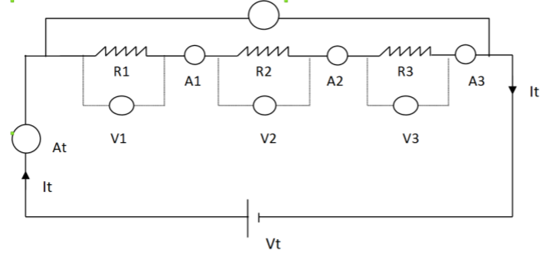
Figure 1: Three resistors connected in series form
A series circuit is a closed circuit in which the current follows one path. In a series circuit, the current through each charge is equal and the total voltage across the circuit is the sum of the voltages across each charge.

The currents pass through each resistor are equal.
I_{t} = I₁ = I₂ = I₃
Equivalent resistor is equal to sum of resistors.
R_{eq} = R₁ + R₂ + R₃

The potential difference is equal to the sum of the potential differences of each resistor.
V_{t} = V₁ + V₂ + V₃
as a result.
$$I_{t}= \frac{V_{t}}{R_{1} + R_{2} + R_{3}}$$
$$I_{t }=\frac{V_{t}}{R_{eq}}$$

Resistors in Parallel Combination
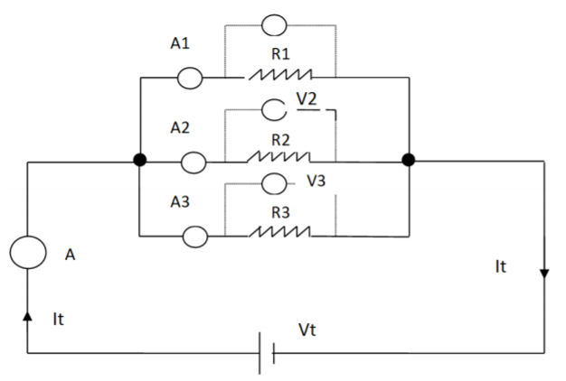
Figure 2: Three resistors connected in parallel form
A parallel circuit is a closed circuit in which the current divides into two or more paths. Each load connected in a separate path has the full circuit voltage, and the total circuit current is equal to the sum of the singular currents.
The currents of the parallel circuit having three divaricates is.
$$I_{1 }=\frac{V_{1}}{R_{1}}$$
$$I_{2 }=\frac{V_{2}}{R_{2}}$$
$$I_{3 }=\frac{V_{3}}{R_{3}}$$

The potential difference on each divaricate is equal.
Vt = V₁ = V₂ = V₃
Total current is equal to the sum of the currents on each divaricate.
I_{t} = I₁ + I₂ + I₃
The equivalent resistance is.
$$\frac{1}{R_{eq}}=\frac{1}{R_{1}}+ \frac{1}{R_{2}}+\frac{1}{R_{3}}$$

Series and Parallel Combination of Resistors
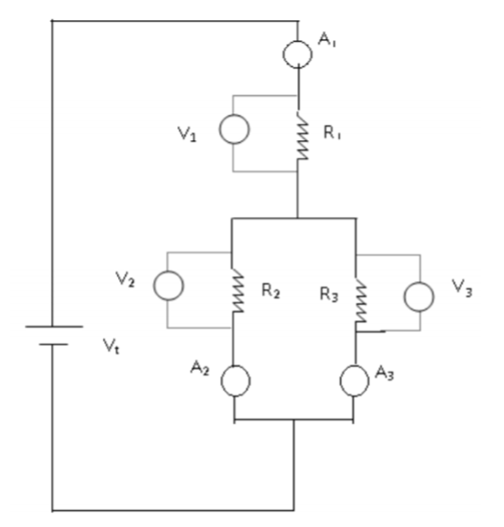
Figure 3: Combination of serial and parallel resistors
A circuit having both series and parallel resistor is a circuit that is a hybrid of series paths and parallel paths. The formulas above can be adapted and used on this circuit.
3-) EXPERIMENTAL SETUP
- Board x1
- Dc voltage source x1
- Digital multimeter x2
- Connection cables 40cm x3
- Connection cables 25cm x4
- Connection cables 15cm x5
- Resistors x3
Firstly, calculate the value of the resistance that you are going to use through the table and calculate it with multimeter. Link resistance, as above schemes. Multimeter test and record equal resistance before adding voltage to circuit. Apply ' voltage supply ' to all chain. Create four link scheme that is given on board below and measure voltage on each resistance. Calculate the current passing by and fill out the table. Calculate the equivalent resistance for each system, and equate the original resistance equivalent value with the value you get. Calculate the error in percentage instead. Compare the current that passes all circuit and voltage branches on all circuit branches with the total current that passes in circuits and the voltage applied on the entire circuit. If a discrepancy occurs state the reasons for this disparity. Create serial and parallel circuits randomly, and then calculate their resistance equivalent. Compare those values to the abstract values later on. Bring your assumptions into context.
4-) CALCULATIONS & RESULTS
Table 1: Theoretical voltage, current and resistor values
Figure (1) | V₁=1.08V | V₂=3.27V | V₃=0.654V
Figure (1) | R₁=33Ω | R₂=100Ω | R₃=20Ω
Figure (1) | I₁=0.0327A | I₂=0.0327A | I₃=0.0327A
Equivalent resistance 1: 153Ω
Figure (2) | V₁=5V | V₂=5V | V₃=5V
Figure (2) | R₁=33Ω | R₂=100Ω | R₃=20Ω
Figure (2) | I₁=0.15A | I₂=0.05A | I₃=0.25A
Equivalent resistance 2: 11.1Ω
Figure (3) | V₁=3.66V | V₂=1.865 | V₃=1.85V
Figure (3) | R₁=33Ω | R₂=100Ω | R₃=20Ω
Figure (3) | I₁=0.111A | I₂=0.0187A | I₃=0.0925A
Equivalent resistance 3: 49.7Ω

Table 2: Measured voltage, current and resistor values
Figure (1) | V₁=1.06V | V₂=3.27V | V₃=0.66V
Figure (1) | R₁=38.0Ω | R₂=104.2Ω | R₃=26.1Ω
Figure (1) | I₁=0.0330A | I₂=0.0323A | I₃=0.0327A
Equivalent resistance 1: 168.3Ω
Figure (2) | V₁=4.77V | V₂=4.79V | V₃=4.86V
Figure (2) | R₁=38.0Ω | R₂=104.2Ω | R₃=26.1Ω
Figure (2) | I₁=0.150A | I₂=0.060A | I₃=0.250A
Equivalent resistance 2: 13.5Ω
Figure (3) | V₁=3.39V | V₂=1.79V | V₃=1.79V
Figure (3) | R₁=38.0Ω | R₂=104.2Ω | R₃=26.1Ω
Figure (3) | I₁=0.090A | I₂=0.020A | I₃=0.072A
Equivalent resistance 3: 58.9Ω

5-) CONCLUSION
The total current flowing through a series circuit and parallel circuit, the voltage at each resistor and the current flowing through a series circuit and parallel circuit are determined in this experiment; the relationship between the voltages at each resistor and the total voltage is studied, and the relationship between the current flowing through each resistor and the total current. Current and voltage are detected using Ohm's Law, via a series and parallel circuit. From our experiment it is understood this form of arrangement from the table in which the results are obtained.
6-) REFERENCES
- Marmara University Faculty of Engineering Laboratory Manual
- https://en.wikipedia.org/wiki/Series_and_parallel_circuits
- https://www.physicstutorials.org/pt/97-Combination_of_Resistors
- Hugh D. Young, Roger A. Freedman; University Physics with Modern Physics, 14th Edition,2014
7-) APPENDIX